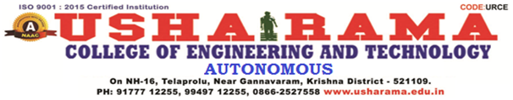
DEPARTMENT OF COMPUTER SCIENCE AND ENGINEERING
ASSIGNMENT-1 EXAMINATION
Year/Sem :III B.Tech, II Sem | Programme: III B.Tech, CSE | Course Code: UR20PCCS503
Course Name: BDA | Total marks:5 | Time:60min
Level: Bloom’s Taxonomy (Level 1-6)
Answer all questions:
1 | what is Big Data and Explain the main features of BD.
2 | Draw a lifecycle of Analytical process.
3 | Explain in detail about Nature of data and its applications.

CO1: Illustrate big data challenges in various domains.
CO2: Apply techniques for mining data streams.
CO3: Design and develop Hadoop-based solutions.
CO4: Compare trivial data with big data across applications.
CO5: Assess search methods and visualization techniques

